INTRODUCTION

 Machine learning is a subfield of artificial intelligence, which is broadly defined as **the capability of a machine to imitate intelligent human behavior**. Artificial intelligence systems are used to perform complex tasks in a way that is similar to how humans solve problems.The algorithms are used in a wide variety of applications, such as in medicine, [email filtering](https://en.wikipedia.org/wiki/Email_filtering), [speech recognition](https://en.wikipedia.org/wiki/Speech_recognition), [agriculture](https://en.wikipedia.org/wiki/Agriculture), and [computer vision](https://en.wikipedia.org/wiki/Computer_vision), where it is difficult or unfeasible to develop conventional algorithms to perform the needed tasks

1.1 project overview

                                     Chatbots  are software applications that mimic human speech to simulate a discussion or communication with a genuine individual. Chatbots measure the content introduced to them by the user, prior to responding as indicated by a complex series of algorithms that deciphers and recognizes what the user said, deduces what they mean, and decides a progression of fitting responses dependent on this data. The flaw in this technology is that, majority of the chatbots support English language only and not many have the expertise to impart in numerous dialects. We can’t expect all the users using this technology to know and communicate in English, and despite that, a study shows that individuals are inclined toward imparting in their local language since it's more convenient.In this research aim to address this problem and focus on modelling  a new mullitilinguial chotbot for to ease the

1.2 purpose

**2.LITERATURE SURVEY**

2.1existing problem

2.2reference

 2.3problem statement definition

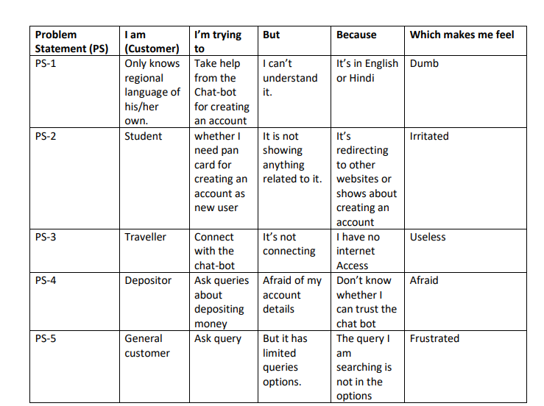

**3 .IDEATION AND PROPOSED SOLUTION**

3.1 Empathy map canvas

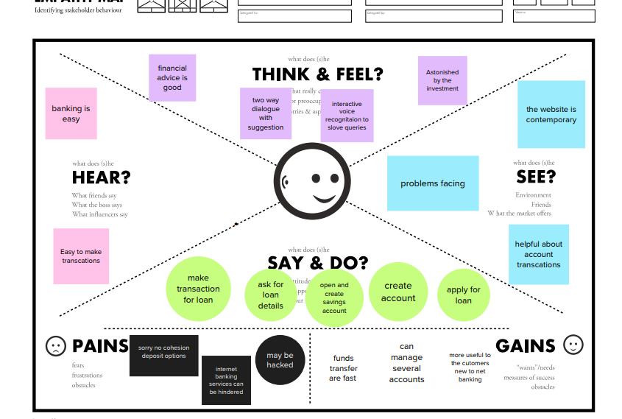

3.2 Ideation and Brainstorming

1. Multilingual chat-bot:

• While interacting with a chat-bot, customers prefer having conversations in their native language.

• However, creating a separate chat-bot for each language is neither feasible nor economical for organizations

. • A multilingual chat-bot or a polyglot bot is capable of supporting and conducting conversations in multiple languages to amplify your reach and scale your localization efforts.

• Customers generally trust brands that offer services in their native language more than the ones who don’t.

• Multilingual chat-bots speak to users in different languages, across regions and countries and accelerate your localization efforts

2. SMS Chat-bots:

• SMS Chatbots are a convenient way for businesses to interact with customers, prospective customers, and employees.

• A chatbot is an artificial intelligence system that can interact with humans through natural language messages

. • It provides automated responses to customer inquiries, answers frequently asked questions, and offers recommendations for products or servicesSMS Chatbots are a convenient way for businesses to interact with customers, prospective customers, and employees

. • A chatbot is an artificial intelligence system that can interact with humans through natural language messages.

• It provides automated responses to customer inquiries, answers frequently asked questions, and offers recommendations for products or services.

• WhatsApp Chatbot helps automate your sales and customer support. Engage everyone who matters for your business on the largest messaging app

. • Website chatbot helps to automate customer support, improve marketing activities, and generate leads.

• Let the chatbot solve routine & common queries

3. Machine learning:

• Machine learning query optimization changes this by learning from actual query performance and iterating on the suggestion it makes for which path the query should take.

• In this way, it mimics neural network patterns to learn from experience. Machine learning is an important component of the growing field of data science.

• Through the use of statistical methods, algorithms are trained to make classifications or predictions, and to uncover key insights in data mining projects.

• These insights subsequently drive decision making within applications and businesses, ideally impacting key growth metrics

. • As big data continues to expand and grow, the market demand for data scientists will increase

. • They will be required to help identify the most relevant business questions and the data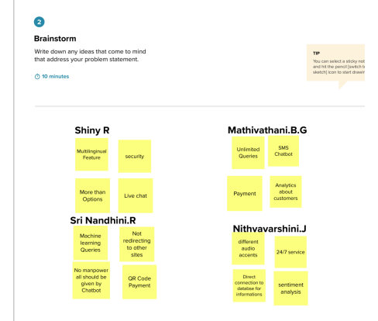

3.3 proposed solution

• Problem Statement (Problem to be solved)

Chat-bots are used in different applications in the modern age. In banking Industry the chatbot is used instead of customer service to reduce time and manpower. As the chat-bot is used in very efficient way it can be used only by a well-educated person who knows English or Hindi. This affects the normal persons who don’t know the language’s and this comes as a disadvantage for chat-bot.

• Idea / Solution description Multilingual chat-bot or a Polyglot bot:

A Multilingual Chatbot allows enterprises to converse with users speaking various languages enhancing engagement and conversions. Traditional chatbot technology holds a limitation of conducting a conversation only in one specific language. For example, if you have your business in China, your website might have a chatbot that converses in Mandarin. On the other hand, multilingual chatbots are capable of conversing in multiple languages – not just translation. Gone are the days where multilingual meant “Translate and Understand”. Building multilingual chatbots requires more than just processing text or dialogue in English through a language translator. To effectively converse in multiple languages, a chatbot must be aware of the end-users’ culture and able to understand regional nuances. This needs additional time and effort during the development phase

. • Novelty / Uniqueness

There are many chat-bots which has bilingual or trilingual features but not the multilingual feature. Here we add the major Regional languages of India to make it more customers friendly. Audio Search also is translated from different regional languages to chat-bot language and the queries will be answered in regional language itself. • Social Impact / Customer Satisfaction • Reduce Costs • Expand Your Customer Base With Localization • Boost Efficiency • Break Down Language Barriers

• Business Model (Revenue Model)

Informs the customer of the available services Informant makes the data search quickly and easily. The Chatbot could aggregate information from different sources and conduct push notifications to the user about changes in the interested services. It’s one of the most attractive options for your business. Helps the customer:The Informant makes a data search quick and easy. The Chatbot could aggregate information from different sources and conduct push notifications to the user about changes in the interested services. • Scalability of the Solution With a multilingual chatbot, they can easily use the conversational features on website/app and scale it to many languages. Once we have built the chatbot, they can launch it in different languages. With more users, chatbot will be able to grow. Thus, chatbot can be used to provide customer support in multiple languages, thereby increasing its global reach and ultimately growing usage. With an app, will be able to integrate the conversational features into the website without having to integrate the website with each chatbot.

3.4 problem solution fit

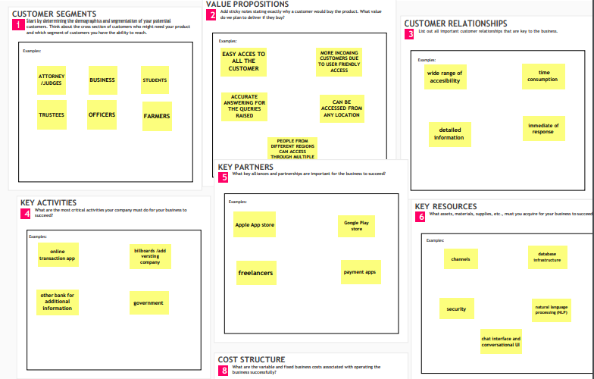

**4.REQUIREMENT ANALYSIS**

4.1 Functional requirement

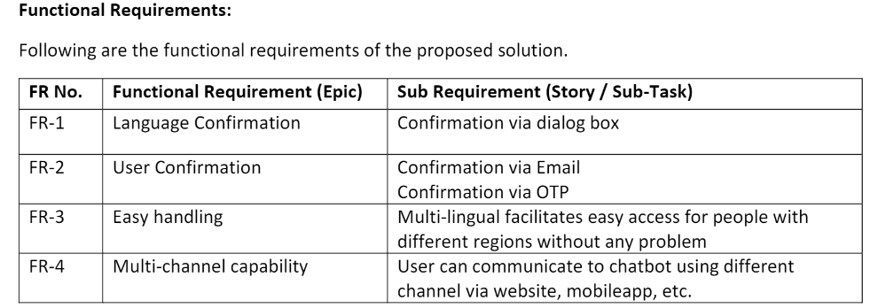

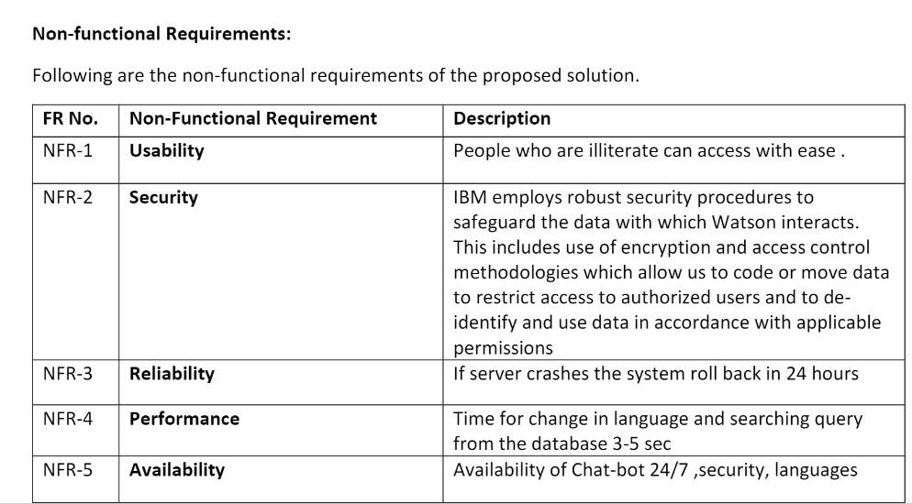

**5. PROJECT DESIGN**

5.1 DataFlow Diagrams

DFD LEVEL 0

1. The IBM Watson assistant has trained with identity,entites and roles and given to chatbot

2. The question in chatbot are given to ibm assistant

3. The suggestions,answers,reasons for the questions are given by assistant

4. Cutomers are the one who gives the question

DFD LEVEL 1

1.there are two actors in the Chatbot system: a IBM Watson Assistant and an administrator. The IBM Watson Assistant is tasked to provide questions and answers to the system as explained previously.

2. Meanwhile, the administrator’s responsibility is to provide initial questions.

3. In the DFD level 1, the Chat -bot system is detailed to three subprocesses: (1) provide role and identity, (2) response to a question, and (3) add a question.

4. The first and second subprocesses belong exclusively to the IBM watson assistant, while the third process is shared between the IBM watson assistant and the administrator.

5. The first subprocess stores the role and identity of the IBM watson assistant and stores them in the users' table

. 6. The second subprocess handles the process where the IBM watson assistant answer or reject the question.

7. Whether it is an answer or a rejecting reason, the data is stored in the answer table flagged with different statuses.

8. The third sub -process is responsible to receive question input from both the IBM watson assistant and administrator in different cases: input question suggestion for the IBM watson assistant and add initial questions for the administrator.

9. This subprocess takes a question as an input and store the question and question category in their respective table.

10. The question category explains whether the question is provided by the IBM watson assistant or the administrator.

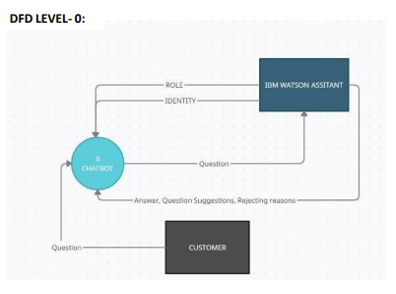

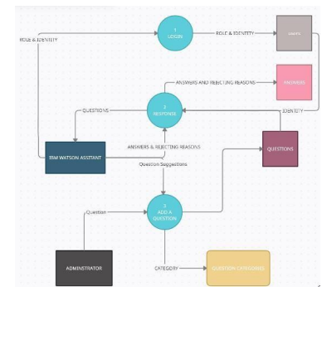

5.2 Solution and Technical Architecture

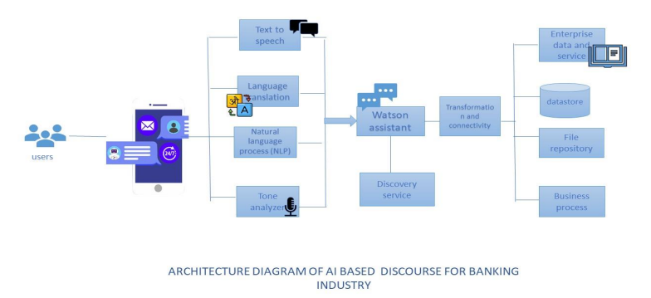

5.3 User Stories

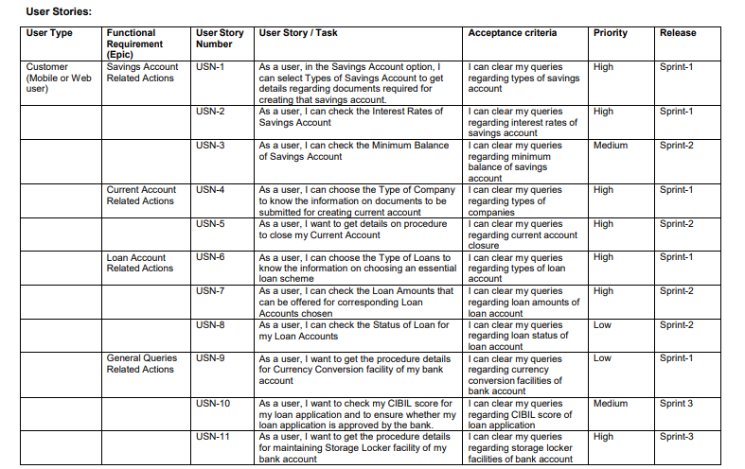

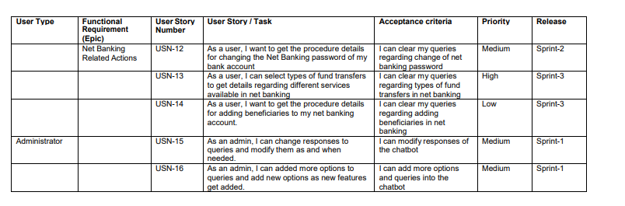

**6. PROJECT PLANNING AND SCHEDULING**

6.1 Sprint Planning and Estimation

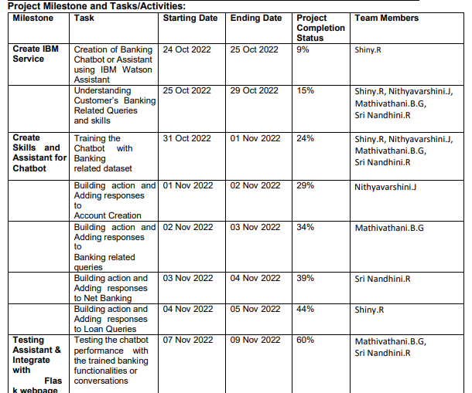

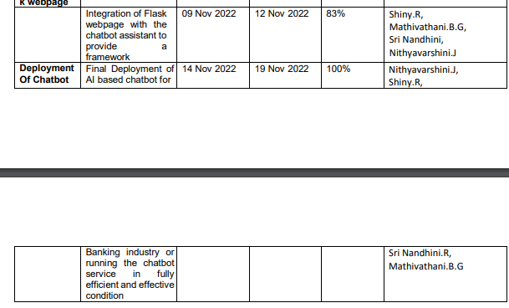

6.2 Sprint Delivery Plan

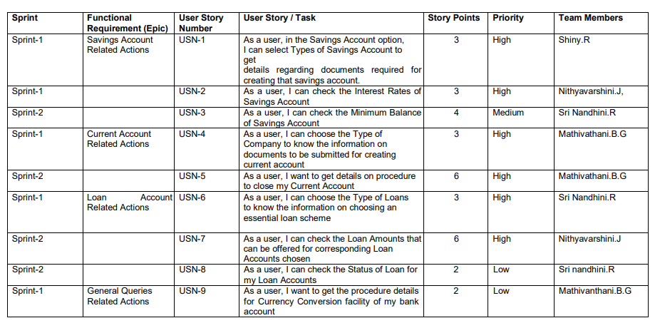

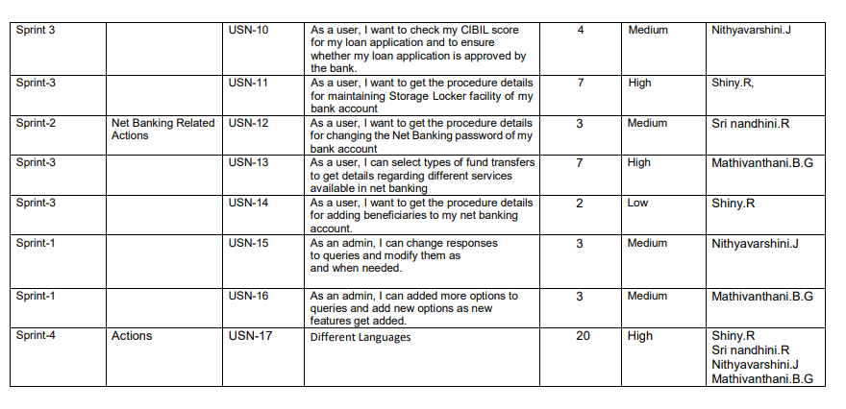

6.3 Report From JIRA

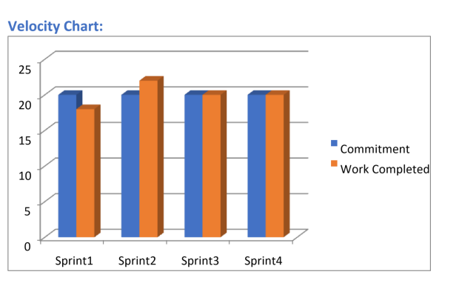

BURNDOWN CHART

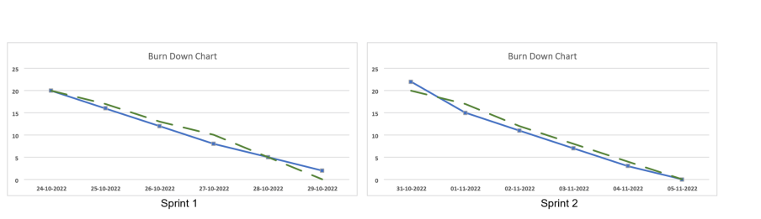

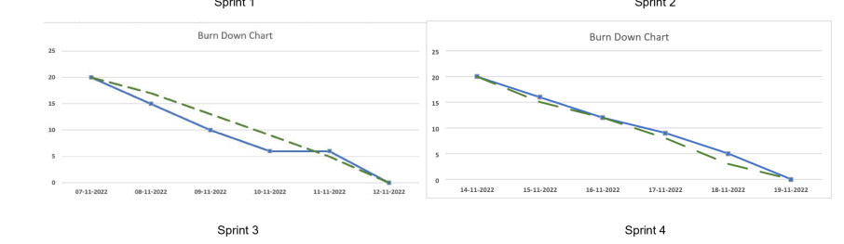

SUMMARY STANDUP :

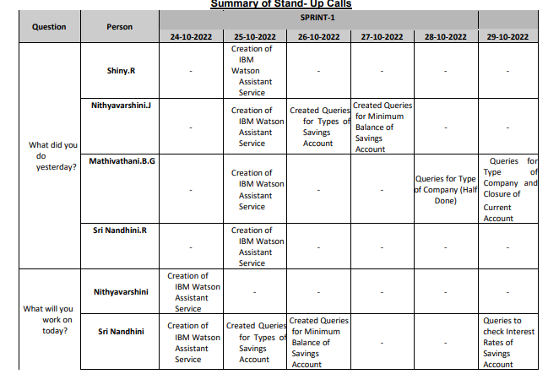

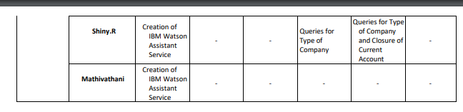

**8.TESTING**

8.1 Test case

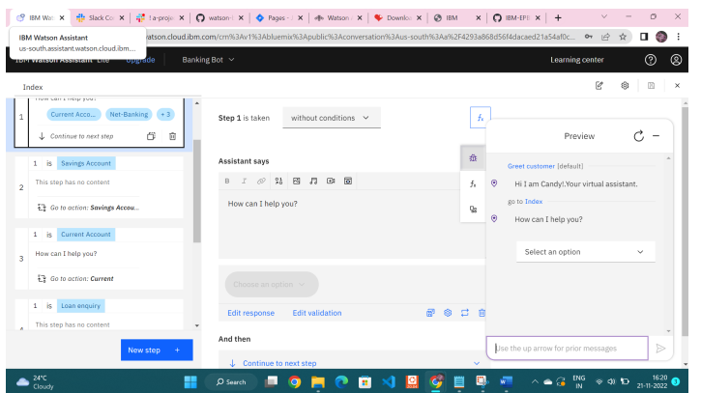

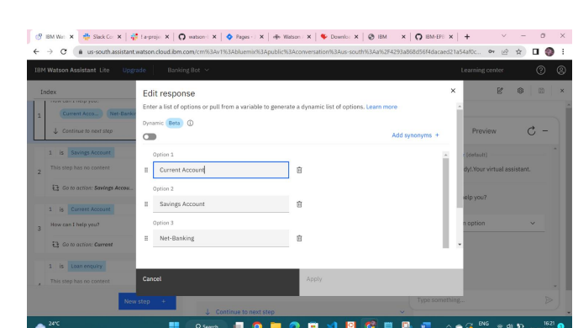

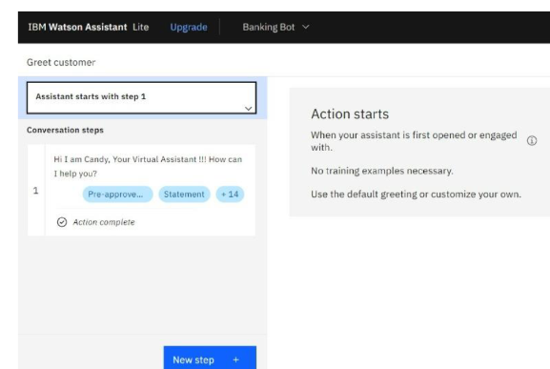

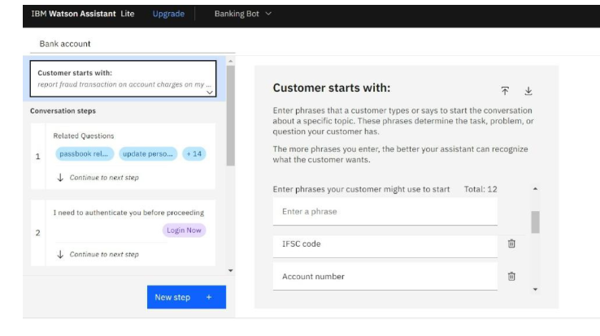

**13. APPENDIX**

**SOURCE CODE**